Tianle Yuan
CS 550
October 19, 2020
Project 3

Name: Tianle Yuan
Email: yuant@oregonstate.edu
Project Number: 3
Project Name: Texture Mapping
Web Link: https://media.oregonstate.edu/media/t/1_e5wu2obf
Screen Captures：

My blob-ish ball:
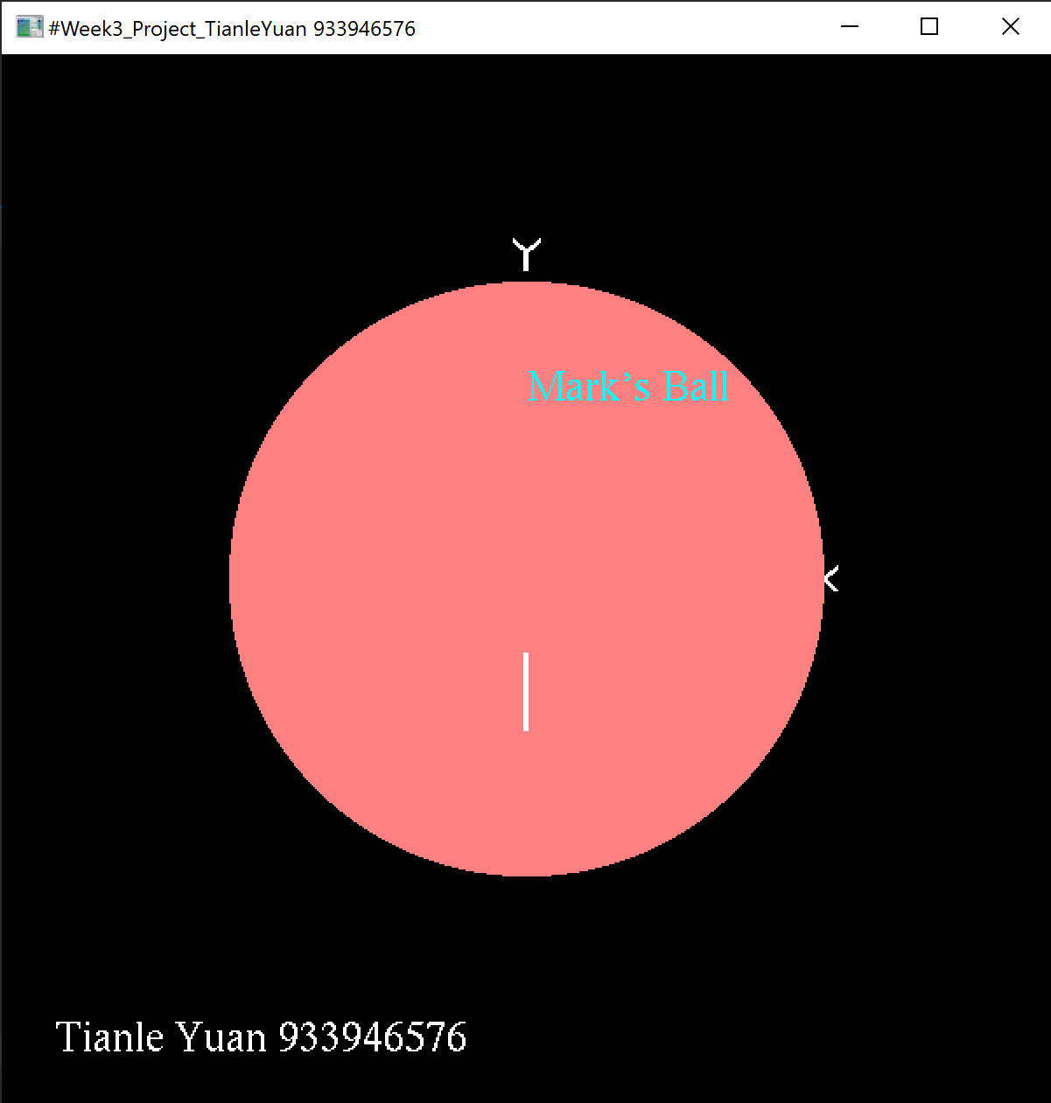

My normal-textured ball:
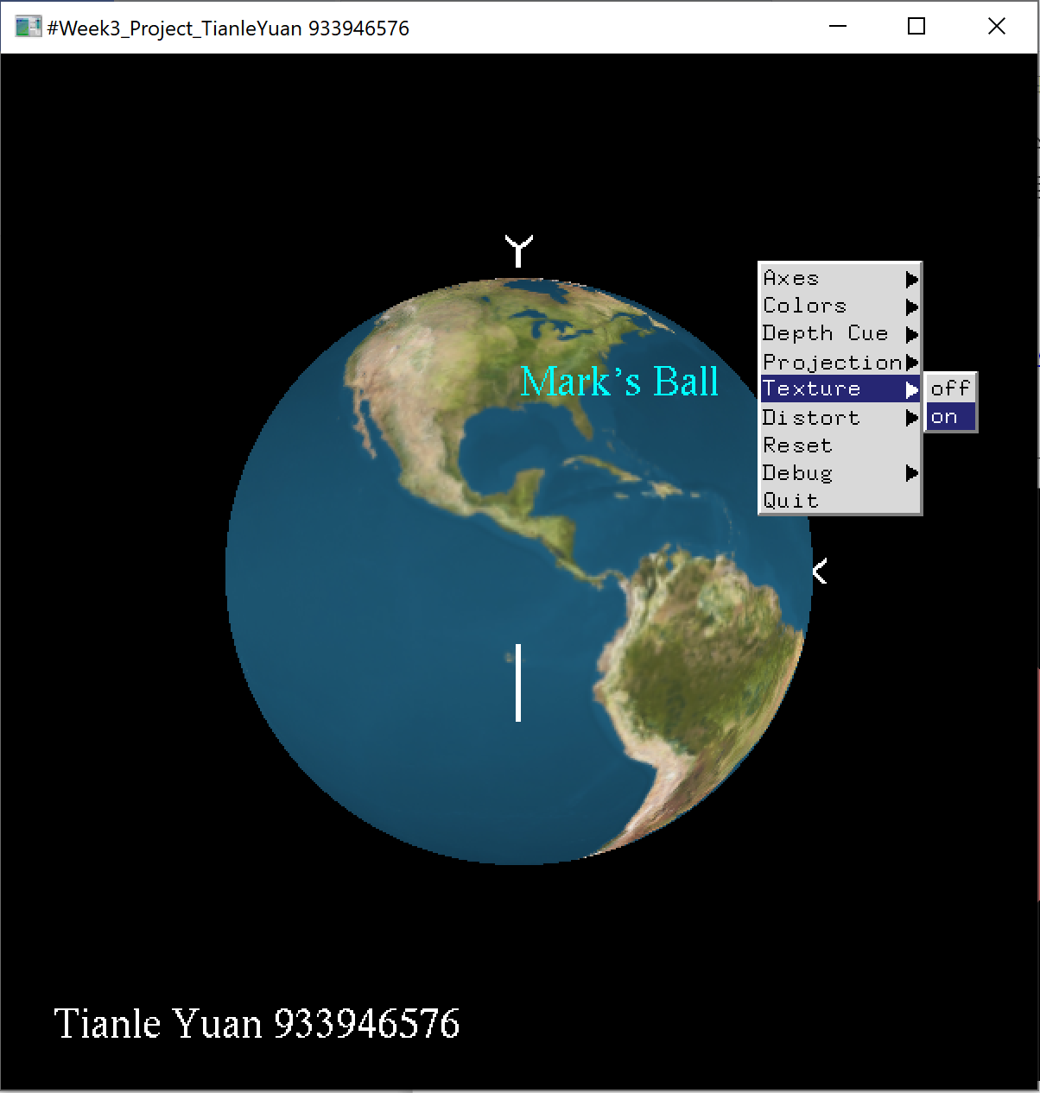

My distorted-textured ball:

